
How to add a category:
- Navigate to ITube/New and select the html document you want to add the category to
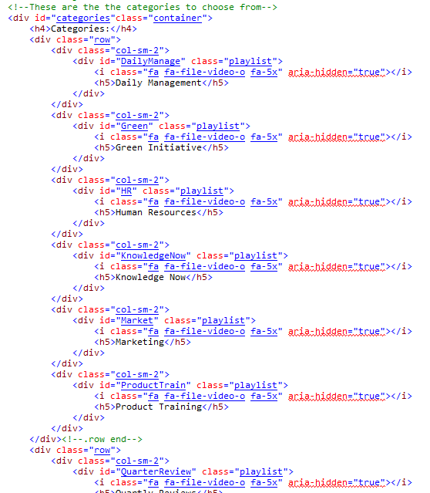
- Look for this section on the document:

Here you’ll find row(s) with 6 <div>’s per row. Select an entire div.col-sm-2 and paste it into the next available spot. Make a new row if need be. Make sure there’s only 6 <divs> per row as it will mess up the rows.

- Now it’s time to update the info in the div you just pasted
  - The div nested inside div.col-sm-2 has id and class attributes
    - The id attribute is very important. This should be an intuitive name that describes the playlist. Remember this name for later.
    - The class attribute should be “playlist” by default. Don’t change it.
  - Inside the div.playlist there is an <i> with some stuff in it. Don’t touch this.
  - The <h5> is the title that will appear on the page for the user. Change this to whatever makes sense to you.
  - Save and your playlist button should be on the I-Tube
- With your button all set you need to create the page that will load the videos. Pressing the button will show a back button and no videos at this point.
  - Navigate to ITube/New/playlists and select the relevant folder. For example, if I added my category to the MISC page I would go to ITube/New/playlists/MISC
  - This is where the id from earlier comes into play. In the folder you navigated to you’ll want to create an html document that has the same name as the id from earlier.
  - To create this document you can use ITube/New/templates/galleryTemplate.html and then just add your videos.
- Your category should now be working on the I-Tube


How to add a subcategory:
- If you would like to add a category within a category follow these instructions.
  - An example of this can be seen on the misc. page on I-Tube. If you click on the “marketing” category you can see another category appears called “sales training sessions” that has its own videos.
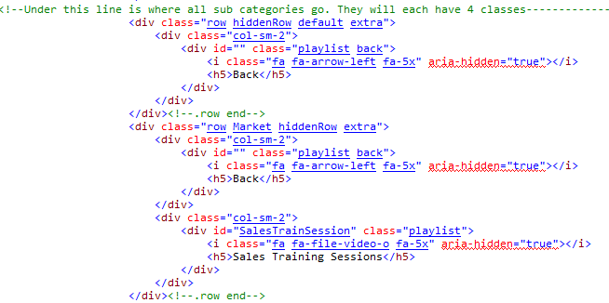
- Like with a normal category, open up the html page that you want to add the subcategory to. Look for a section like this:

Each row in this section has 4 classes. These rows are hidden initially and the only one that every page will have is the one with “row hiddenRow default extra” as the class.

- Your subcategory will have its own row. Copy the entire div with “row hiddenRow default extra” class and paste it underneath the line with the <!--row end--> comment.
  - Change the class from “default” to the id of the category you want to add it to. For example, the Marketing category on the MISC page has a subcategory. The Marketing category has an id of “Market,” so there is a row that has a class of “row Market hiddenRow extra.” See the picture above for reference.

- Inside the div you just pasted there should be another div that has an <h5> in it that says “Back.” Leave this there. On the line after it ends is where you can out your subcategory button.
  - From here it’s basically just like adding a normal category. Follow the steps for adding a category and you’ll be good to go.

TIP: Because of the way I designed this system, adding a subcategory is unfortunately complicated. However, if you just copy the format the Marketing category on the Misc. uses it’s only a matter of copy and pasting and changing a couple of lines.

